PUBLIC JOINT-STOCK COMPANY COMMERCIAL
BANK «PRIVATBANK», CYPRUS BRANCH
3, Kallipoleos avenue, Geogas Tower, 3 floor,
CY-1055, Nicosia, Cyprus
Tel: +35722750378, Fax: +35722750608

Dear Sirs!
PrivatBank offers a favorable way of payroll accounting
for Ukrainian seamen working on board vessels of your
and your partners companies.
With our offer you save a lot on commissions on payments,
reduce money depositing time and optimise the process
of salary payment as a whole.

3 ways of paying salaries to your personnel
1. Transfer, free of charge, salaries from the company’s account with PrivatBank (Cyprus) indo seamen’s accounts opened with PrivatBank (Ukraine)!

The money is deposited within one business day. You get access to the Privat24 Internet banking which allows making payments from any country in the world.
2. Transfer salaries in a single payment into the account of a company opened with PrivatBank (Cyprus) and then distribute the money between corporate accounts issued by the Cyprus branch.

You will only need to send the payment order and the payroll with a breakdown of the amount into seamen accounts to the bank. The money will be deposited to corporate accounts free of charge. The bank will send cards to any country worldwide!

3. Transfer crew members, repair team members and office employees’ salaries in one single payment into the company transit account opened with PrivatBank (Ukraine). You will only need to specify card numbers and the amounts to be charged using the SFTP protocol in the payroll. The money will be deposited to PrivatBank (Ukraine) payment accounts free of charge.

In order for this method to work, a separate transit account is opened with PrivatBank (Ukraine) in EUR or USD, a relevant agreement is concluded between the company and the bank.

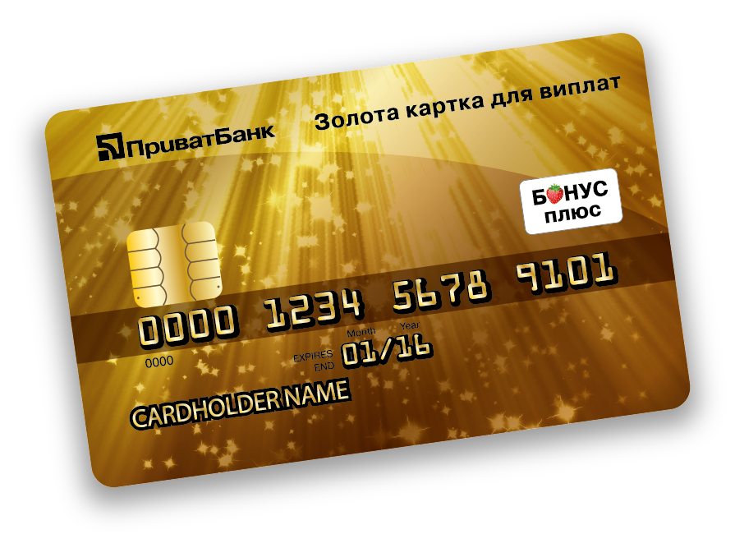
Gold­level cards for seamen

We offer free instantaneous issue gold cards for seamen Ukraine which they could use to receive salaries.

Advantages of a Gold­level card
- The card is available in any currency (EUR, US dollars, UAH).
- There's no fee for cash withdrawals at cashier's desks and ATMs of the PrivatBank,
ATMs of any other banks in the territory of Ukraine, as well as at cashier's
desks and ATMs of the partner banks abroad.
- Get your card within 10 minutes.
- Possibility of issuing additional cards for seaman’s relatives.
- Participation in the Bonus Plus and PrivatBank VIP discount programs.

For 10 years of cooperation with the leading shipping and crewing companies of the world,
tens thousands of seamen and members of their families became clients of PrivatBank.
Such companies as Marlow Navigation Co. Ltd, Marcrew Schiffahrts GmbH, Calista LLC, Chesva Enterprises Ltd and many others are among our partners.

We hope that your company will benefit from our offer.
We will be happy to answer any questions you might have and consider any counter offers.

Yours sincerely,
Vladyslav Morgachov
General Manager of PJSC CB «PRIVATBANK»
Cyprus Branch

About the bank
- PrivatBank was founded in 1992 and is now the leader of the banking system in Ukraine. The bank offers high­quality products and services, innovational technologies which allow clients to get banking services via the Internet, mobile applications, and self­service terminals.
- PrivatBank international bank group provides services to more than 22 million clients in 10 countries of the world, including Latvia, Italy, Portugal, China, Great Britain, Cyprus, Germany, Spain, and Kazakhstan. According to the data of the RIA Rating agency, PrivatBank is among the TOP­10 CIS banks, and takes 9th place among the ten largest banks of the Central and Eastern Europe in the TOP­1000 world banks rating.
- Full­fledged member of the Visa International and MasterCard International payment systems.
- Cyprus Branch of the PrivatBank operates since 1999 and is the first and is the only branch of a Ukrainian bank which
has an official permission of the National Bank of Ukraine and the Central Bank of Cyprus to work in the Republic of Cyprus.
- Cyprus Branch of PrivatBank was annually awarded by Deutsche Bank Bankers Trust Company Americas with the STP Excellence Award among all banks of Greece and Cyprus from 2004 to 2012 inclusive.
- Please visit en.pb.ua to get more detailed information about the bank

